NAMAL-MEDCARE (NMC)

Project Proposal
V 1.0
By
 | Names | Roll Numbers | Email Addresses
1 | Muhammad Touseef Akhtar | 40 | bscs25f40@namal.edu.pk
2 | Anaya Nawal | 10 | bscs25f10@namal.edu.pk
3 | Atayyib Hassan | 12 | bscs25f12@namal.edu.pk
4 | Sobia Nosheen | 55 | bscs25f55@namal.edu.pk



Department of Computer Science
Namal University
Mianwali, Pakistan
Submission Date: 9th October 2026
GitHub Repository Link: https://github.com/Muhammad-Touseef-Akhtar/Namal-MedCare

REVISION HISTORY
Date | Version | Description | Approved by
9th October, 2026 | V 1.0 | Initial project proposal submission detailing requirements baseline. | Ms. Asiya Batool

TABLE OF CONTENT
1. INTRODUCTION…………………………………………………………………4
2. PROBLEM STATEMENT…………………………………………………………4
3. PROJECT OBJECTIVES………………………………………………………….4
4. PROJECT SCOPE………………………………………………………………….5
5. STAKEHOLDER IDENTIFICATION…………………………………………….6
6. SOFTWARE DEVELOPMENT METHODOLOGY……………………………...6
7. TOOLS AND TECHNOLOGIES…………………………………………………9
REFERENCES………………………………………………………………………...

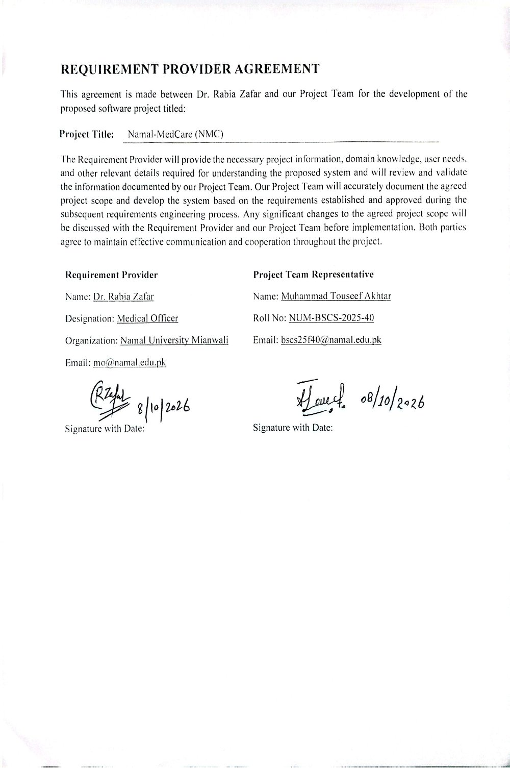

INTRODUCTION:
The medical department at Namal University provides essential healthcare services to students, faculty, and staff on campus [3]. Throughout their academic stay, students rely on the campus clinic for routine checkups, minor illnesses, and immediate medical attention. To support this, the clinic must maintain accurate records of patient demographics, ongoing treatment histories, and the current stock levels of medications available in the university dispensary [3].

The proposed system, Namal-MedCare (NMC), is a digital campus health management solution designed to provide a centralized platform for the university medical officer [4]. The system replaces isolated manual notebooks with a structured digital framework. It organizes patient profiles, logs daily clinical consultations, maps prescription history, and tracks dispensary inventory. This digital system aims to provide the doctor with immediate data access, supporting safer clinical decisions and more efficient dispensary tracking on a single interface [4].

PROBLEM STATEMENT:
Namal University's medical department manages all patient profiles and dispensary inventory through manual paperwork and physical ledgers. Because maintaining extensive health fields on paper for thousands of students is too difficult, the current manual registers completely omit critical health data such as blood groups, medical histories, and specific allergy details. This lack of data creates severe operational gaps during routine check-ups and poses a dangerous threat during on-campus medical emergencies. If a student needs urgent medical attention or immediate blood-type matching, the clinic has no record to check, making it impossible to assist them quickly [4].

Additionally, managing the dispensary manually makes it impossible to track medicine batches accurately. Without automated calculations, the clinic staff cannot easily identify which medications are running low or approaching their expiration dates. This lack of tracking leads to human errors where essential drugs either run out unexpectedly or expire silently on the shelves, creating preventable safety hazards and administrative overhead for the campus healthcare team [3].

PROJECT OBJECTIVES:
The core goal of the Namal-MedCare (NMC) project is to build and deploy a comprehensive, secure, and centralized health informatics platform that replaces manual paper-based tracking workflows. To evaluate the success of the system, the project aims to achieve the following specific objectives:
- To build and deploy a secure digital database system that allows the university doctor to view a patient's complete medical history and verified blood group within seconds of entering their roll number or employee ID.

- To implement a high-speed search and filtering function for emergency scenarios, enabling medical staff to locate matching student blood types instantly when an urgent transfusion need arises on campus.

- To integrate a real-time automated alert engine that displays critical allergies or chronic conditions on the doctor’s screen the exact moment a patient's digital profile is opened.

- To develop a fully functional dispensary inventory module that tracks medications by batch number and automatically cross-references the expiration dates with the system's local calendar date to flag items nearing expiration.

- To fully implement a secure, multi-user web application using Python for backend logic and MySQL for storage, establishing clear role-based access for the university medical officer and authorized dispensary administrators.

- PROJECT SCOPE:
The proposed Namal-MedCare (NMC) system will provide a centralized digital platform for managing medical records and medicine inventory at the Namal University dispensary. The system will replace the current manual record-keeping process and allow authorized medical personnel to efficiently record, update, search, and retrieve relevant information.

- Patient Record Management: The system will maintain relevant patient information, including basic personal details, department, year, allergies, relevant medical history, doctor visits, diagnoses, and prescribed or issued medicines.

- Inventory Tracking Control: It will also maintain medicine inventory records, including quantities, batch numbers, expiry dates, and minimum stock levels. The system will support the recording of medicine issuance against patient visits and help authorized dispensary staff monitor medicine availability and expiry information.

- Role-Based Security Framework: Patient medical information will be treated as confidential. Access to patient records will be restricted to the Medical Officer and specifically authorized medical or dispensary staff of the university medical unit. Other university personnel, students, or unauthorized users will not have access to confidential patient medical records. The system will use user authentication and role-based access controls to restrict users to information relevant to their responsibilities.

- Search and Retrieval Facility: The system will provide search facilities for authorized medical staff to reduce the need to manually search through physical registers. The project will focus on digital medical-record and medicine-inventory management within the university dispensary. It will not replace the doctor’s professional judgment, diagnosis, or treatment decisions and will function as a record-management and inventory-support system.
- STAKEHOLDER IDENTIFICATION:

The following stakeholders are relevant to the Namal-MedCare (NMC) system. Access to confidential patient medical records is limited to authorized medical and dispensary personnel.

Table 1: Stakeholders and Their Roles in the Proposed System
Stakeholder | Role | Interaction with System
Medical Officer – Dr. Rabia Zafar | Requirement provider and primary medical user. | Records and review patient visits, relevant medical history, allergies, diagnoses, and prescribed or issued medicines.
Authorized Medical / Dispensary Staff | Manage day-to-day medical and dispensary operations. | Enter and update authorized records, record medicine issuance, and manage medicine inventory according to assigned permissions.
Students / Patients | Recipients of medical services. | Their relevant medical information and visit/medicine records are maintained in the system. They do not have general access to the confidential medical records database.
System Administrator / Technical Support | Maintains the technical operation of the system. | Manages system configuration, user accounts, permissions, backups, and technical maintenance. Access to confidential medical information is restricted according to the system's authorization policy.

6. SOFTWARE DEVELOPMENT METHODOLOGY:
6.1 Selected Methodology
Our project team will follow the Agile Scrum methodology for the development of the Namal-MedCare (NMC) system. Work will be divided into structured, two-week sprints where each iteration focuses on delivering a functional, reviewable component of the system. This methodology aligns perfectly with a one-year development timeline and allows our team to incrementally design the front-end layout before expanding it into a full database-driven application.
This approach suits the development of the Namal-MedCare (NMC) system for four concise reasons:
• Continuous Stakeholder Feedback: The system serves multiple distinct users including Dr. Rabia Zafar, clinical assistants, and dispensary staff. Iterative cycles ensure these users can verify interface fields, low-stock thresholds, and security views early in the lifecycle, [2].
• Multi-Semester Management: Since the project spans consecutive stages, an incremental approach allows the visual blueprints and data schemas built now to serve as a stable foundation for full system implementation later, [4].
• Modular Architecture: The system consists of highly independent modules, such as patient record tracking, consultation logging, and dispensary inventory management. Scrum allows our team to design, build, and test each component independently before final system integration.
• Risk and Cost Reduction: Traditional plan-driven models like Waterfall delay user testing until late in the schedule. Using Scrum allows our team to catch logic errors or data gaps early, preventing expensive modifications close to deployment, [4].

6.2 Development Phases
The core software engineering phases are executed iteratively across successive sprints to deliver a robust, fully functional campus health system, [3]:
- Planning: Define project boundaries, objectives, stakeholder roles, and the one-year schedule. The main output of this initial phase is this formal project proposal document.

- Analysis: Elicit functional and non-functional requirements from Dr. Rabia Zafar through manual register reviews and interviews. Requirements are documented in a Software Requirements Specification (SRS) using the MoSCoW prioritization technique, [5].

- Design: Construct the overall system architecture, UML use-case models, relational entity-relationship diagrams (ERDs) in MySQL, and interactive interface screens, [4].

- Implementation: Develop comprehensive application logic. This involves coding the server-side logic, deploying database tables, and building role-based front-end panels. All tasks are managed on dedicated Git feature branches.

- Testing: Run detailed unit and integration tests to verify critical logic pathways, including low-stock threshold triggers, expiration date comparisons, and user login permissions, [6].

- Delivery: Deploy the functional system on the campus infrastructure, migrate legacy paper registers, conduct medical staff training, and hand over all operational manuals, [4].

6.3 Team Organization and Progress Monitoring
The four-member project team operates in time-boxed, two-week sprints. The Scrum Master role will rotate among team members to facilitate meetings and clear development roadblocks. Project tasks, the product backlog, and sprint boards are managed transparently using a public GitHub Projects board divided into To Do, In Progress, In Review, and Done columns. To ensure absolute patient privacy and record confidentiality, the public repository boards will use dummy data exclusively for all progress monitoring, dashboard testing, and development metrics. Sprints initiate with team planning sessions and conclude with formal review demonstrations for our instructor and requirement provider.
6.4 Feedback and Process Management
Feedback gathered during sprint reviews is logged directly as active issues within the GitHub workspace. Any proposed modification to the agreed project scope undergoes a rigorous impact assessment regarding team effort, project resources, and schedule adjustments. Changes are only accepted upon mutual agreement between our project team and Dr. Rabia Zafar. Approved modifications are immediately updated within the main Revision History table, and stable baselines are tagged directly in Git for secure version control.
6.5 Tentative Schedule
The project is mapped across a one-year development window running from October 2026 to September 2027. Sprints track the project sequentially through core academic milestones, mapping out requirements engineering, database and logic design, component implementation, validation testing, and final system deployment.

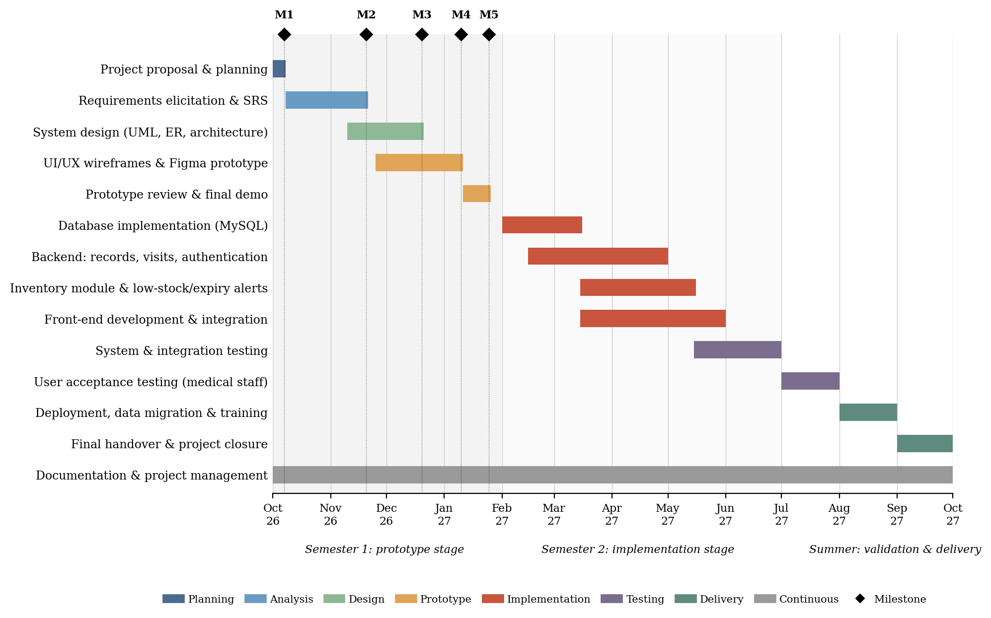
Figure 1: Tentative One-Year Project Schedule and Course Milestones

7. TOOLS AND TECHNOLOGIES:
The tools below were chosen because they are free or available under student licenses, are well documented, and fit a web-based medical records and inventory system. Python, [12] with the Django framework, [8] is proposed for the backend because it provides built-in authentication, permission handling, and database access, which are needed to protect sensitive health records; the lighter Flask framework, [9] was considered as an alternative. MySQL, [11] provides the relational integrity needed for patient, visit, and inventory data. Figma, [10] and the HTML5, CSS3, and JavaScript stack, [13] support the full system creation.

Table 2: Proposed Tools and Technologies
# | Tools and Technology | Purpose
1 | Figma [10] | To design interactive UI/UX wireframes, front-end models, and clickable prototypes of the doctor, dispensary, and administrator interfaces, and to collect user feedback before coding starts.
2 | MySQL [11] | To model and implement the relational database that securely stores patient profiles, doctor visit records, multi-year (four-year) student health history, blood groups, and medicine inventory logs with batch numbers and expiry dates.
3 | Python [12] with Django [8] | Proposed as the backend language and framework to handle data logic, user authentication, role-based access, medical record retrieval, and the generation of low-stock and expiry alerts.
4 | HTML5, CSS3, and JavaScript[13] | To build the structure, styling, and client-side behavior (such as form validation) of clean, responsive client-facing interfaces.
5 | Bootstrap [14] | A CSS framework used with the front-end stack to obtain a responsive layout and ready-made components, speeding up prototype development.
6 | Git and GitHub [7] | To maintain version control, collaborate within the student team, track issues, run the sprint board, and manage milestone documentation submissions.
7 | draw.io (diagrams.net) [15] | To draw UML (use case, class, sequence), ER, and data flow diagrams for the analysis and design documents.
8 | MySQL Workbench [11] | To create the ER model visually, generate the database schema from it, and test SQL queries during implementation.
9 | Visual Studio Code [16] | The code editor for Python, HTML, CSS, and JavaScript development, with Git integration.
10 | Django Test Framework [8] | To write and run automated unit and integration tests for the backend modules, including the alert logic and access control.
11 | Microsoft Word | To compile, structure, and maintain all formal software engineering documentation, including the proposal, SRS, and design documents.

REFERENCES
[1] K. Schwaber and J. Sutherland, “The Scrum Guide,” Scrum.org, Nov. 2020. [Online]. Available: https://scrumguides.org/scrum-guide.html (accessed Oct. 8, 2026).
[2] K. Beck et al., “Manifesto for Agile Software Development,” 2001. [Online].
Available: https://agilemanifesto.org/ (accessed Oct. 8, 2026).
[3] I. Sommerville, Software Engineering, 10th ed. Harlow, U.K.: Pearson, 2016.
[4] R. S. Pressman and B. R. Maxim, Software Engineering: A Practitioner’s Approach, 9th ed. New York, NY, USA: McGraw-Hill Education, 2020.
[5] Systems and Software Engineering — Life Cycle Processes — Requirements Engineering, ISO/IEC/IEEE Standard 29148:2018, 2018.
[6] OWASP Foundation, “OWASP Top 10:2021.” [Online].
Available: https://owasp.org/Top10/ (accessed Oct. 8, 2026).
[7] GitHub, Inc., “GitHub Docs.” [Online]. Available: https://docs.github.com/ (accessed Oct. 8, 2026).
[8] Django Software Foundation, “Django documentation.” [Online].
Available: https://docs.djangoproject.com/ (accessed Oct. 8, 2026).
[9] Pallets, “Flask documentation.” [Online]. Available: https://flask.palletsprojects.com/ (accessed Oct. 8, 2026).
[10] Figma, Inc., “Figma Help Center.” [Online]. Available: https://help.figma.com/ (accessed Oct. 8, 2026).
[11] Oracle Corporation, “MySQL Documentation.” [Online].
Available: https://dev.mysql.com/doc/ (accessed Oct. 8, 2026).
[12] Python Software Foundation, “Python 3 documentation.” [Online].
Available: https://docs.python.org/3/ (accessed Oct. 8, 2026).
[13] Mozilla, “MDN Web Docs: HTML, CSS and JavaScript.” [Online].
Available: https://developer.mozilla.org/ (accessed Oct. 8, 2026).
[14] Bootstrap Team, “Bootstrap documentation.” [Online].
Available: https://getbootstrap.com/docs/ (accessed Oct. 8, 2026).
[15] JGraph Ltd., “diagrams.net (draw.io) documentation.” [Online].
Available: https://www.drawio.com/doc/ (accessed Oct. 8, 2026).
[16] Microsoft, “Visual Studio Code documentation.” [Online].
Available: https://code.visualstudio.com/docs (accessed Oct. 8, 2026).

